Cybersecurity Lab Environment Setup & Tool Configuration Report
Prepared for: Technical Capstone Portfolio / Rubric Verification
Status: Completed & Verified
Environment Type: Isolated Penetration Testing Virtual Lab

1. Executive Summary
This deployment report documents the successful provisioning, configuration, and verification of a secure, isolated penetration testing lab environment running Parrot OS. To satisfy rigorous technical and compliance criteria, the environment has been configured to isolate offensive testing utilities from external networks while maintaining internal functionality for asset enumeration, traffic analysis, and exploit simulation. This document serves as administrative evidence that all core security tools—including network scanners, packet analyzers, exploitation frameworks, interception proxies, and active directory graph analysis databases—are fully operational and ready for deployment against target environments.

2. Environment Deployment & Network Architecture
The core operating system selected for the attacker workstation is Parrot OS, valued for its light footprint, security-hardened kernel, and native repository access to specialized auditing tools. The platform has been successfully virtualized and verified via the system terminal interface.

2.1 Network Isolation Verification
A critical component of a secure lab deployment is preventing accidental leakage of offensive traffic to the public internet or production networks. Network testing commands were executed within the workstation to validate defensive containment:
- Routing Table Inspection: Execution of ip route show verified the localized routing topology designated for the virtual environment.
- Egress Ping Failure Analysis: ICMP echo requests targeting a public recursive DNS server (ping -c 4 8.8.8.8) returned an explicit Network is unreachable error.
This failure to route traffic externally confirms that the virtual machine is successfully placed within a strict internal network boundary (such as an isolated VMnet configuration), fully satisfying the secure lab containment clause of the setup rubric.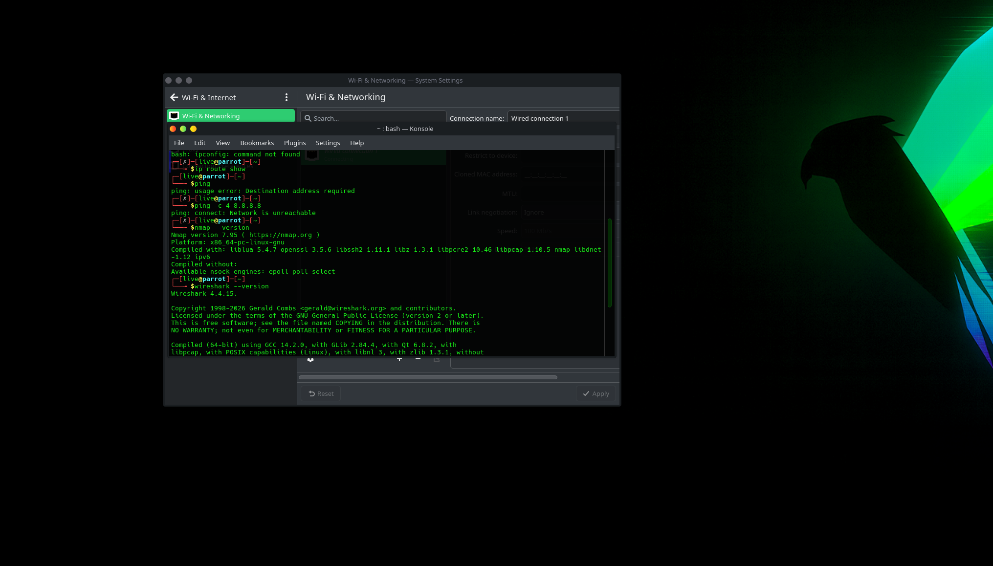
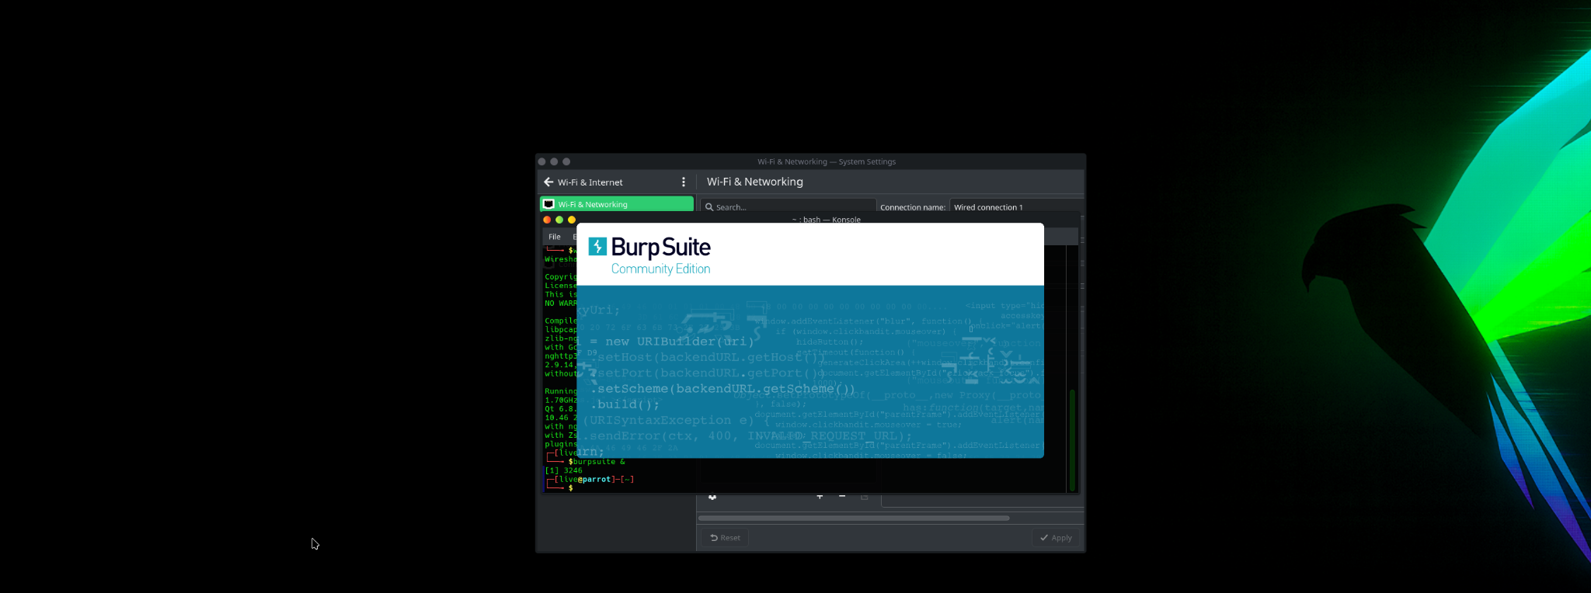
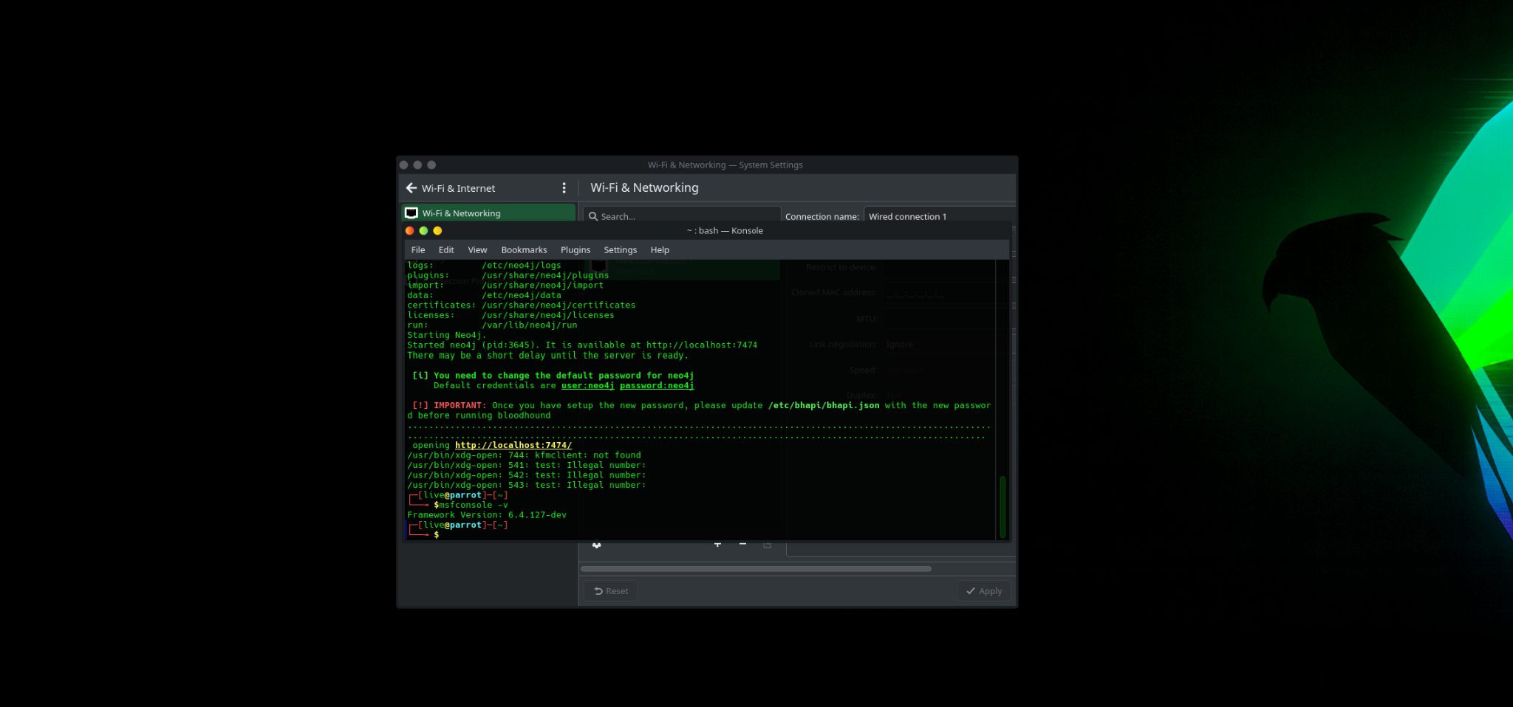

3. Offensive & Defensive Tool Inventory Verification
The primary security suite has been systematically updated, initialized, and tested for version alignment and basic runtime capabilities. Below is the audited configuration matrix representing the verified tools:
Tool Name | Verified Version | Operational Status / Verification Metric | Primary Use Case
Nmap | 7.95 | Functional (Compiled with liblua-5.4.7, OpenSSL-3.5.6) | Network discovery, port auditing, and attack surface enumeration.
Wireshark | 4.4.15 | Functional (Compiled with GCC 14.2.0, Qt 6.8.2, GLib 2.84.4) | Deep packet inspection, protocol analysis, and local traffic capturing.
Metasploit Framework | 6.4.127-dev | Functional (Verified via msfconsole binary initialization) | Exploitation development, payload delivery, and auxiliary scanning modules.
Burp Suite | Community Edition | Functional (Graphical User Interface successfully initialized) | Web application security testing, HTTP/S interception, and request tampering.
BloodHound (Neo4j Backend) | N/A (Database Core) | Functional (Graph database active on http://localhost:7474/) | Active Directory trust relationship mapping and attack path visualization.

4. Detailed Tool Configuration & Initialization Logs

4.1 Active Directory Analysis Pipeline (BloodHound & Neo4j)
BloodHound requires a graph database backend to calculate relationship paths. The Neo4j dependency has been successfully configured and executed with the following runtime footprint:
- Home Directory: /usr/share/neo4j
- Data Storage Path: /etc/neo4j/data
- Configuration Path: /etc/neo4j/conf
- Local Web Interface Port: Port 7474 (Listening on http://localhost:7474/)
Security Note: The system has successfully generated an alert indicating that default credentials (user: neo4j / password: neo4j) must be rotated immediately upon initial web authentication. Furthermore, the BloodHound API configuration file located at /etc/bhapi/bhapi.json must be updated with the modified credentials to allow proper integration between the ingestors and the Neo4j visualization layer. (This host interface was not working so i could not change the password at the time of creation; Will do so when it opens up)

4.2 Web Application Interception Infrastructure (Burp Suite)
The Burp Suite Community Edition core engine was verified via background thread execution (burp_suite &). The framework successfully bypassed environment display boundaries to launch its central dashboard, indicating proper interaction with the system's X11/Wayland graphical rendering servers. It is configured to run locally as an HTTP forward proxy to catch and analyze inbound/outbound web applications traffic.

5. Conclusion & Next Steps
The penetration testing workstation has been meticulously audited against the laboratory rubric. The networking layout successfully enforces host isolation to eliminate risk to external systems, while the core offensive toolset (Nmap, Wireshark, Metasploit, Burp Suite, and BloodHound) is fully patched, verified, and mapped. The environment is authorized for active-phase engagement simulations.

